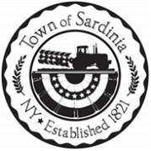
Town of Sardinia Regular Board Meeting December 11, 2025 at 6:30pm

TOWN BOARD MEMBERS
Supervisor Beverly Gambino
Councilwoman Kathleen Becker
Councilman Krissy Kittleson
Councilman Len Hochadel
Councilman Matt Krist

Also Present:
Highway Superintendent Christopher Dabolt
Town Clerk Jennifer L. Bray
Approx. ________ Guests

Meeting called to order by Supervisor Gambino at ___________________pm
Roll Call

Pledge of Allegiance

Approval of Minutes
- November 13, 2025 November Regular Meeting
- November 13, 2025 Public Hearing Community Development Block Grant Funding
- November 13, 2025 Public Hearing 2026 Budget

Approval of Bills

Report from Deputy Shane Miller

Adjournment


