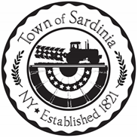

**Town of Sardinia – Regular Scheduled Board Meeting July 11, 2024**

**TOWN BOARD MEMBERS**

Supervisor Beverly Gambino

Councilwoman Kathleen Becker

Councilman Ethan Dabolt

Councilman Len Hochadel

Councilman Matt Krist

**Also Present**:

Highway Superintendent Christopher Dabolt

Town Clerk Jennifer L. Bray

Approx. ________ Guests

Meeting called to order by Supervisor Gambino at ___________________pm

Roll Call

**Pledge of Allegiance**

**Approval of Minutes**

1. **Regular Board and Public Hearing on Fire Protection Contract June 13th 2024**

**Approval of Bills**

**Discussion/Update**

**EXECUTIVE SESSION (if necessary)**

**ADJOURNMENT**