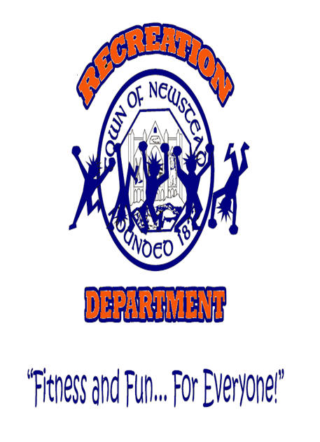

“LET’S CAN HUNGER!” FOOD DRIVE
The 19th Annual “Let’s Can Hunger!” food drive, sponsored by the Newstead Recreation Department, aims to collect boxed, canned, and non-perishable food items for the local food pantry serving the Akron-Newstead community. Starting Tuesday, 7/28, youth are encouraged to bring canned goods, boxed items, and non-perishable food products to their respective staff members during check-in. Please be sure to check expiration dates to ensure quality. The Can Drive is scheduled to conclude on Tuesday, 8/4. Youth collecting the most items are eligible to receive a Gift Certificate, courtesy of the Candy Apple Café.

“LET’S CAN HUNGER!” FOOD DRIVE
The 19th Annual “Let’s Can Hunger!” food drive, sponsored by the Newstead Recreation Department, aims to collect boxed, canned, and non-perishable food items for the local food pantry serving the Akron-Newstead community. Starting Tuesday, 7/29, youth are encouraged to bring canned goods, boxed items, and non-perishable food products to their respective staff members during check-in. Please be sure to check expiration dates to ensure quality. The Can Drive is scheduled to conclude on Tuesday, 8/4. Youth collecting the most items are eligible to receive a Gift Certificate, courtesy of the Candy Apple Café.

