Farmers Market Coupons 2025
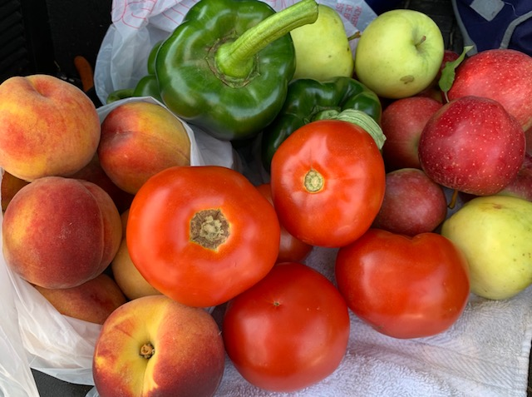
Pictures of fresh fruits and vegetables bought at the East Aurora Farmers Market
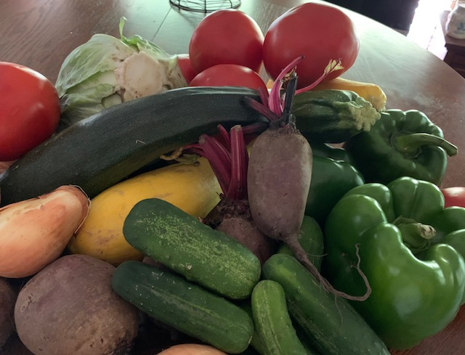

Erie County Department of Senior Services’
Stay Fit Dining Program

Will be distributing coupons at

Akron Newstead Senior Center
Thursday, 7/10/2025
From: 2:30pm To: 4:00pm

All coupon recipients must meet the eligibility requirements
as established by New York State:

- 60 years of age or older
AND
- One person household income is at or less than $2,413
- Two person household income is at or less than $3,261
- Three person household income is at or less than $4,109

One $25.00 booklet issued per person
Coupons will be distributed on a first-come, first-served basis.
You must be present to sign for coupons.

