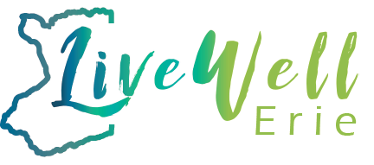

Live Well Erie Working Families Work Group meeting agenda for 4/27/23
8:30am- 8:50- Welcome- Working Families Co-Chairs: Karen King & Maria Whyte
Welcome new subcommittee co-chairs!
Sub-Committee Chairs for 2023
  - Workforce de/re-development and Asset Building – Maria Whyte & Jaqueline Hall
  - Housing- Paul D’Orlando & Sandy Becker
  - Mobility- Frank Cammarata & Kate Hilliman
  - Accessible and affordable quality childcare- Sandy Neubert, Susan Gawley& Vonetta Rhodes
8:50-9:20-
Review updated 2023 community strategies

9:20-9:30-
Community Partner Announcements
Broderick Carson

Upcoming Meeting Dates:
May 25, 2023
June 22, 2023

