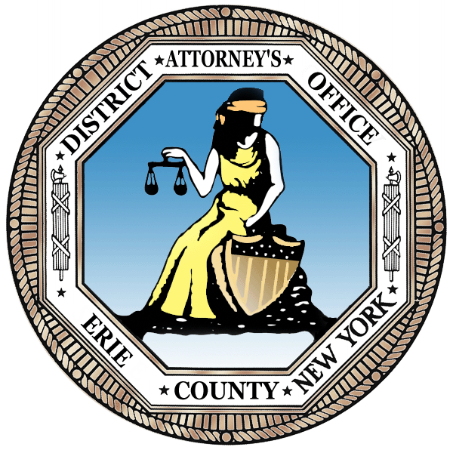
ERIE COUNTY DISTRICT ATTORNEY’S OFFICE
NEWS RELEASE
DISTRICT ATTORNEY JOHN J. FLYNN

FOR IMMEDIATE RELEASE

June 18, 2021

RESTORATIVE JUSTICE PILOT PROGRAM FOR ADOLESCENT OFFENDERS PENDING PROSECUTION IN YOUTH PART

The pilot program is collaborative effort by Erie County DA’s Office, Buffalo Police Department NET & Erie County Restorative Justice Coalition to provide teens with pending criminal cases an alternative to traditional dispositions

BUFFALO – Erie County District Attorney John J. Flynn announces the first installment of a collaborative restorative justice program to provide an alternative to a court disposition in criminal cases involving adolescent offenders. Today, DA Flynn was joined by Thomas Champion of the Buffalo Police Department Neighborhood Engagement Team (NET), and Dina Thompson, Executive Director of the Erie County Restorative Justice Coalition to provide information on the three-part pilot program that launched last month.

Restorative justice is an alternative approach to punishment in the criminal justice system that focuses on the needs of the victims, offenders and their community. It is intended to hold the offender accountable for their actions by focusing on repairing harm, rebuilding trust, restoring relationships and reducing recidivism. Restorative justice practices allow all parties involved to communicate their feelings about the crime while encouraging the offender to reflect on how their behavior has impacted others.

This newly created program is a collaborative effort by prosecutors, law enforcement, the Court, and Erie County Restorative Justice Coalition to encourage the adolescent offender to process the overall impact of their criminal action. It aims to find an effective resolution as an alternative to a criminal conviction that may result in imprisonment or other punishment. It also seeks to educate the adolescent offender and provide them with services in an effort to prevent them from committing another crime again in the future. The program will be available to qualifying adolescent offenders pending prosecution for low-level offenses or those previously convicted in Erie County Youth Part, but may be expanded to involve other “high-risk” youth.

Currently, there are three adolescent offenders, all charged with crimes for their alleged involvement vehicle thefts, enrolled in the pilot program. The first part of the series, which took place in mid-May, was a roundtable discussion with several people who have been the victim of a crime involving a stolen vehicle. The focus of the first part of the series is an upfront, in-person conversation about how crime has impacted the victims’ lives in an effort to help the adolescent offenders gain perspective of the consequences of their choices.

The second part of the series, which occurred in early June, was a larger community conversation involving members of Buffalo Police NET, SNUG and the Buffalo Peacemakers. The conversation focused on identifying youth needs, helping the teens gain understanding on how crime impacts the community, and restoring their trust and building a relationship with law enforcement. The officers conducted a role play with the teens to help them understand the perspective of the officer when there is an encounter and vice versa.

The final stage of the program is an outdoor event with various agencies to offer the teens opportunities for mentorship, job placement and a variety of other services. The pilot program is currently partnered with BestSelf Behavior Health, Buffalo Urban League YOLO Program, Buffalo Peacemakers, SNUG, Mental Health Advocates of WNY, PathStone Corporation, CoNECT (Community Network for Engagement, Connection and Transformation), and Kenny Simmons - Youth Mentoring program.

If the adolescent offender successfully completes all three parts of the pilot program and does not commit any additional crimes in the interim, the Erie County District Attorney’s Office will move to dismiss the pending charges in Youth Part.

“One bad decision does not have to predict a young person’s future. Too often, my office is prosecuting teenagers, many of them repeat offenders, for stealing cars, committing burglaries and other crimes that have a serious impact on the victim and our communities. I recognize that there are a variety of factors that may lead a young person to commit a crime and we’re looking for innovative ways to address this problem. This program provides an opportunity for adolescent offenders learn from their mistakes, change their mindset, alter their behavior, and access services for any help that they may need. We hope that this program will deter these teens from committing crimes in the future and set them on a path for success in life,” said Erie County District Attorney John J. Flynn.

“We need to rethink the way we are doing justice. Locking people away from the community and resources that offer the most help is not working for our city, state or nation. Restorative Justice brings the people most impacted and centers their needs as central to amending the harm caused by crime or conflict. As the offender accepts accountability and responsibility for their harm, the process offers tangible benefits so everyone can move forward in a positive way and the community is better for it,” said Dina Thompson, Executive Director of Erie County Restorative Justice Coalition.

“The Buffalo Police Department took part in the second part of the series where we participated in the peace circle guided by Dina Thompson, encouraging open dialogue and communication between all involved parties. We also conducted various role playing scenarios where the participants were able to experience the perspective of the other party involved in some of our most frequent police interactions so that they could develop an understanding of the officers point of view, challenges and how these incidents directly impact the lives of both parties in addition to the direct impact that it has on the community,” said Captain Tommy Champion of the Buffalo Police Department Neighborhood Engagement Team (NET).

###

