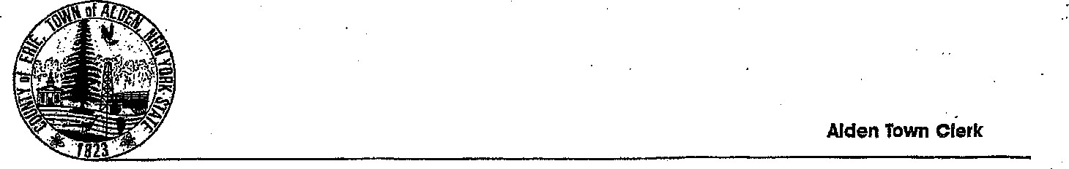

(716) 937-6969 ALDEN TOWN HALL

3311 Wende Road

Alden, New York 14004

# PERMIT FOR ALCOHOLIC BEVERAGES IN COMMUNITY/SENIOR CENTER (2025)

Pursuant to Chapter 95 of the Town of Alden Town Code , known as the "Town Alcoholic Beverages Law", the undersigned is hereby given permission to possess, carry, transport or distribute liquor, wine, beer or other alcoholic beverages in open bottles or other open containers in the Town of Alden Community/Senior Center.

The undersigned individual or organization does agree to assume full responsibility for supervising the conduct of the group or individuals benefiting from such permit and to properly police, clean up and restore the premises after use to the prior condition and also to indemnify the Town of Alden for any and all damages, litigation threatened or commenced against the Town, including legal fees and expenses. This permit shall be available for display upon the request of any policy enforcement officer. The undersigned individual or organization further agrees that adequate precautions must be taken to ensure that minors will not be served or allowed to consume alcoholic beverages at the permitted event or gathering.

The Organization must provide a certificate of insurance to the Town of Alden with the Town named as an additional insured in the minimum amount of $1,000,000 each occurrence and $3,000,000 aggregate to the Town Clerk at least seven (7) days prior to the event. The Organization must provide proof of its NYS Liquor License. Not applicable for individual rentals

No alcoholic beverages shall be distributed or consumed other than on the specified premises described in the permit and only during the time stated.

To sell beer or wine, the organization must hire a caterer with a valid New York State issued off-site liquor license. A copy of said license shall be filed with the application to use Town Facilities along with proof of liquor liability insurance.

All applicants and/or organizations seeking a permit to use the Community/Senior Center shall file an application with the Town Clerk along with any fee required in the form established by Resolution of the Town Board.

The undersigned, for and on behalf of the below named organization, agrees that said organization or applicant will abide by the rules adopted by the Town Board for the use of the Community/Senior Center and also Chapter 122 and Chapter 249 of the Town Code, copies of these rules are posted in the Community/Senior Center, and the undersigned acknowledges receipt of these various rules and regulations.

The undersigned and/or the organization seeking the permit hereby releases the Town of Alden from any liability for personal property left on the premises of the Community/Senior Center by the undersigned or his organization.

Glass containers of any kind are strictly prohibited.

NOTE: THIS IS A SMOKE-FREE BUILDING: There is no vaping, smoking of cigarettes, cannabis or other materials anywhere on Town Property.

NAME _________________________________________________________________

PHONE # ________________________________ Not For Profit: Yes _____ No _____

ADDRESS ______________________________________________________________

TYPE OF EVENT ________________________________________________________

ROOM(S) TO BE COVERED UNDER PERMIT_______________________________

DATE ___________________________ TIME _____________________________

_________________________________ DATED______________________

TITLE OF APPLICANT

Any Problems Call Michelle Gadd (Recreation Director) 716-866-8313

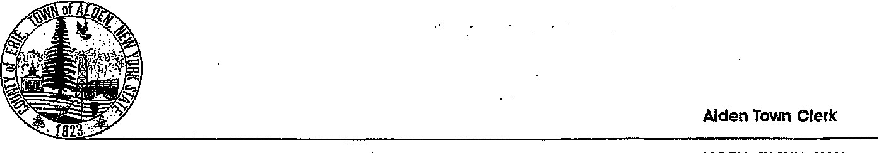

(716) 937-6969 ALDEN TOWN HALL

3311 Wende Road

Alden, New York 14004

# COMMUNITY/SENIOR CENTER USE & PERMIT APPLICATION (2025)

# The undersigned individual or organization does agree to assume full responsibility for supervising the conduct of the group or individuals benefiting from such permit and to properly police, clean up and restore the premises after use to the prior condition and also to indemnify the Town of Alden for any and all damages, litigation threatened or commenced against the Town, including legal fees and expenses. This permit shall be available for display upon the request of any policy enforcement officer. The undersigned individual or organization further agrees that adequate precautions must be taken to ensure that minors will not be served or allowed to consume alcoholic beverages at the permitted event or gathering.

# All applicants and/or organizations seeking a permit to use the Community/Senior Center shall file an application along with any fee required in the form established by resolution of the Town Board:

The undersigned, for and on behalf of the below-named organization, agrees that said organization or applicant will abide by the rules adopted by the Town Board for the use of the Community/Senior Center and Chapter 122 and Chapter 249 of the Town Code, copies of these rules to be posted in the Community/Senior Center, and the undersigned acknowledges receipt of these various rules and regulations.

The undersigned and/or the organization seeking the permit hereby releases the Town of Alden from any liability for personal property left on the premises of the Community/Senior Center by the undersigned or his/her organization.

The undersigned individual agrees to follow the attached Rules.

NOTE: THIS IS A SMOKE-FREE BUILDING : There is no vaping, smoking of cigarettes, cannabis or other materials anywhere on Town Property

NAME* _________________________________________________________________

PHONE # ________________________NUMBER OF ATTENDEES:________________

ADDRESS ______________________________________________________________

TYPE OF EVENT ________________________________________________________

ROOM(S) TO BE COVERED UNDER PERMIT_______________________________

DATE ___________________________ TIME ____________________________

_________________________________ DATED______________________

TITLE OF APPLICANT

Any Problems Michelle Gadd (Recreation Director) 716-866-8313

*Must be a resident of the Town or Village of Alden